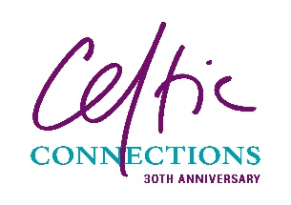
CELTIC CONNECTIONS FESTIVAL SCHOOL CONCERT
APPLICATION FORM 2023
Please complete all sections or there may be a delay in processing your request.
School
Contact
School address, inc. postcode
Contact email
Date of concert
Concert name
Number of seats required
(not including wheelchair spaces or accompanying carers)
Number of wheelchair spaces required
This will include a seat for the carer
How will you be travelling to the Concert Hall | Hired coach □  Public transport □  Walking □
Please note that wheelchair spaces are limited and we may not be able to accommodate all requests.
Completed application forms can be emailed to schoolconcerts@glasgowlife.org.uk
Enquiries should be emailed to schoolinfo@glasgowlife.org.uk – please do not email enquiries to the school concerts email address.
We will have a limited number of parking spaces in the Buchanan Street Bus Station (no cars or minibuses), which will be allocated on a first-come-first-served-basis.
Please indicate if you will require a bus space(s) – Yes □
We occasionally receive requests from media to take photographs during concerts, including of the audience. We realise you may have children in your group who don’t have photo permission.
Are you happy for your group to have their photographs taken? Yes □ No □

